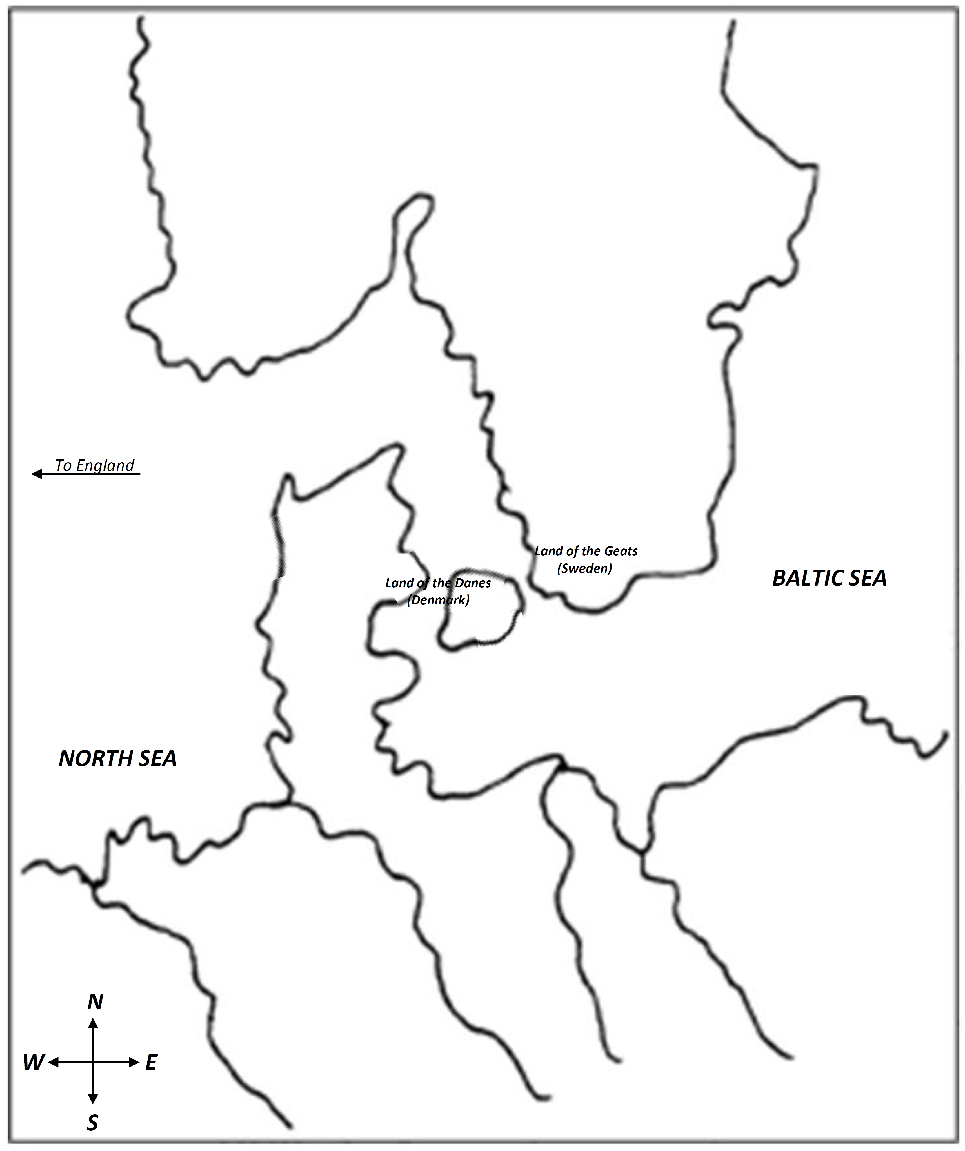

**Higlac**

**C H A R A C T E R M A P**

**Wealthow**

**Edgetho**

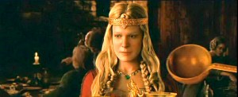

[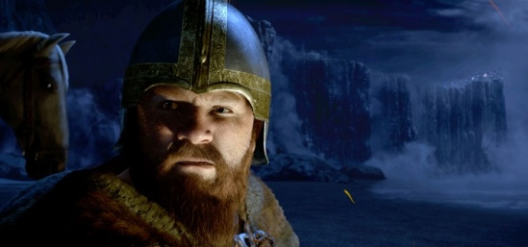](http://www.allmoviephoto.com/photo/2007_beowulf_019_big.html)

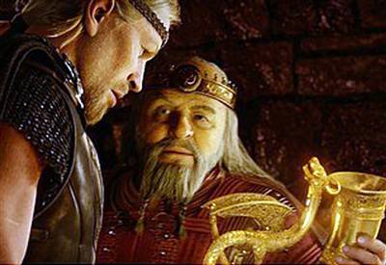

[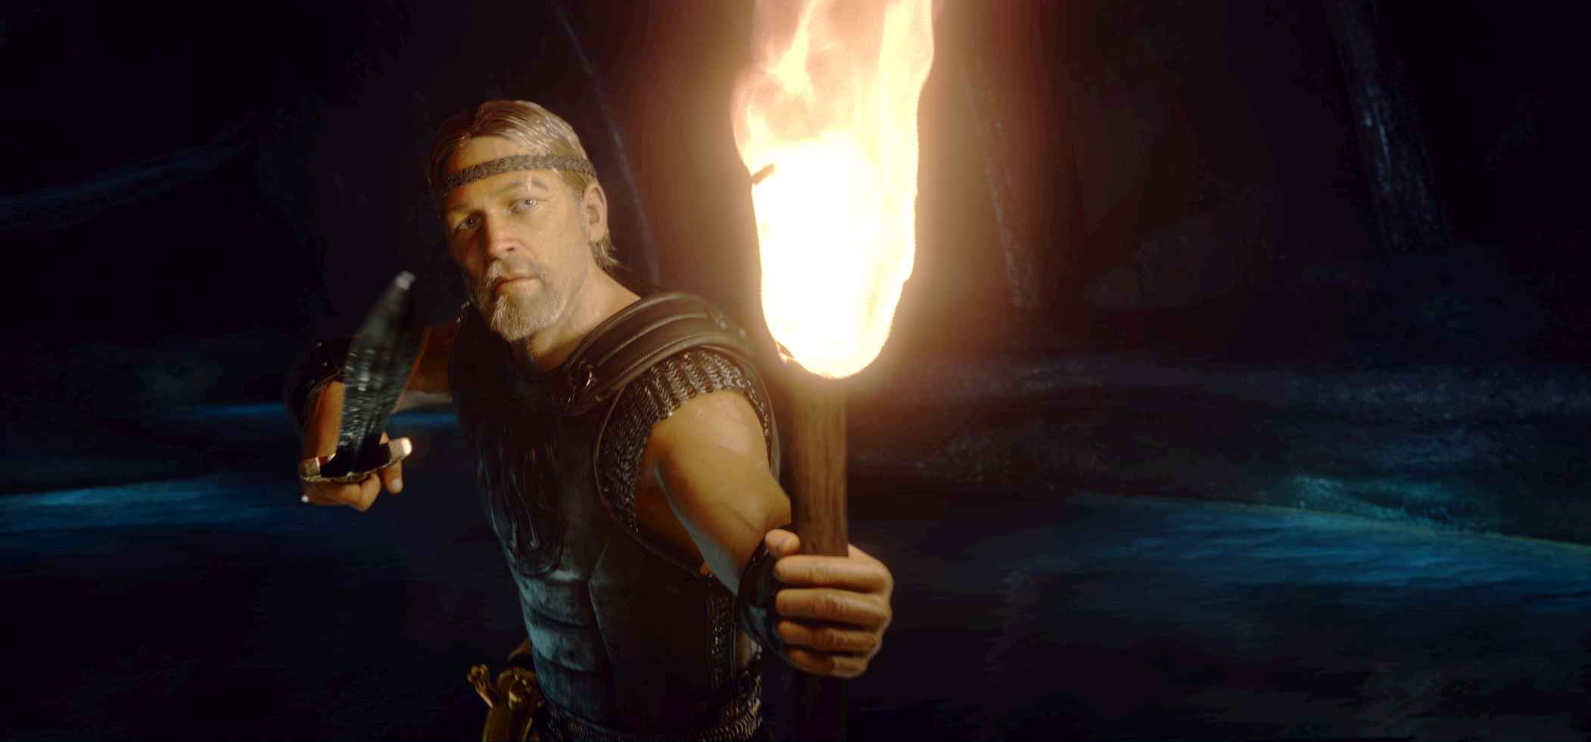](http://www.allmoviephoto.com/photo/2007_beowulf_012_big.html)

**Hrothgar**

**Wiglaf**

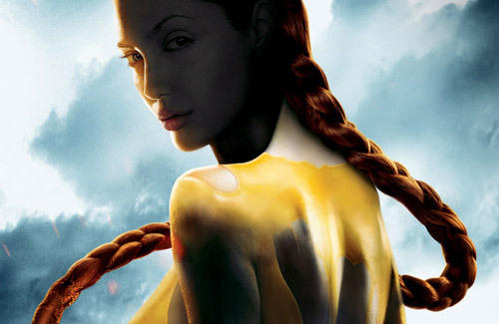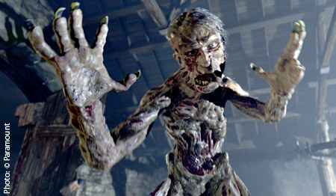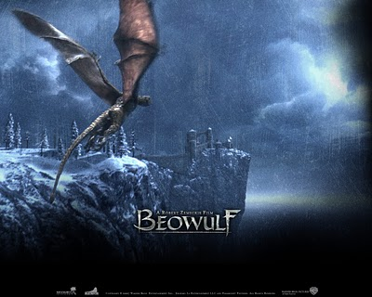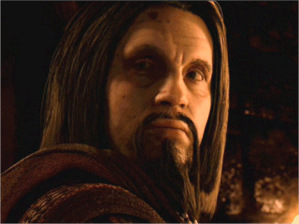

**Beowulf**

**The Dragon**

**Grendel’s Mother**

**Grendel**

**Unferth**

