
Amy Tan

“Two Kinds”

from The Joy Luck Club (1989)

My mother believed you could be anything you wanted to be in America. You could open a restaurant. You could work for the government and get good retirement. You could buy a house with almost no money down. You could become rich. You could become instantly famous.

“Of course, you can be a prodigy, too,” my mother told me when I was nine. “You can be best anything. What does Auntie Lindo know? Her daughter, she is only best tricky.” America was where all my mother's hopes lay. She had come to San Francisco in 1949 after losing everything in China: her mother and father, her home, her first husband, and two daughters, twin baby girls. But she never looked back with regret. Things could get better in so many ways.

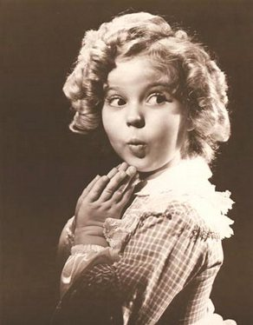
We didn't immediately pick the right kind of prodigy. At first my mother thought I could be a Chinese Shirley Temple. We'd watch Shirley's old movies on TV as though they were training films. My mother would poke my arm and say, “Ni kan. You watch.” And I would see Shirley tapping her feet, or singing a sailor song, or pursing her lips into a very round O while saying “Oh, my goodness.”

“Ni kan,” my mother said, as Shirley's eyes flooded with tears. “You already know how. Don't need talent for crying!”
Soon after my mother got this idea about Shirley Temple, she took me to the beauty training school in the Mission District and put me in the hands of a student who could barely hold the scissors without shaking. Instead of getting big fat curls, I emerged with an uneven mass of crinkly black fuzz. My mother dragged me off to the bathroom and tried to wet down my hair. “You look like a Negro Chinese,” she lamented, as if I had done this on purpose. The instructor of the beauty training school had to lop off these soggy clumps to make my hair even again. “Peter Pan is very popular these days” the instructor assured my mother. I now had bad hair the length of a boy's, with curly bangs that hung at a slant two inches above my eyebrows. I liked the haircut, and it made me actually look forward to my future fame.

In fact, in the beginning I was just as excited as my mother, maybe even more so. I pictured this prodigy part of me as many different images, and I tried each one on for size. I was a dainty ballerina girl standing by the curtain, waiting to hear the music that would send me floating on my tiptoes. I was like the Christ child lifted out of the straw manger, crying with holy indignity. I was Cinderella stepping from her pumpkin carriage with sparkly cartoon music filling the air. In all of my imaginings I was filled with a sense that I would soon become perfect: My mother and father would adore me. I would be beyond reproach. I would never feel the need to sulk, or to clamor for anything. But sometimes the prodigy in me became impatient. “If you don't hurry up and get me out of here, I'm disappearing for good,” it warned. “And then you'll always be nothing.”

Every night after dinner my mother and I would sit at the Formica topped kitchen table. She would present new tests, taking her examples from stories of amazing children that she read in Ripley's Believe It or Not or Good Housekeeping, Reader's Digest, or any of a dozen other magazines she kept in a pile in our bathroom. My mother got these magazines from people whose houses she cleaned. And since she cleaned many houses each week, we had a great assortment. She would look through them all, searching for stories about remarkable children. The first night she brought out a story about a three-year-old boy who knew the capitals of all the states and even the most of the European countries. A teacher was quoted as saying that the little boy could also pronounce the names of the foreign cities correctly. “What's the capital of Finland?” my mother asked me, looking at the story. All I knew was the capital of California, because Sacramento was the name of the street we lived on in Chinatown. “Nairobi!” I guessed, saying the most foreign word I could think of. She checked to see if that might be one way to pronounce Helsinki before showing me the answer.

The tests got harder -- multiplying numbers in my head, finding the queen of hearts in a deck of cards, trying to stand on my head without using my hands, predicting the daily temperatures in Los Angeles, New York, and London.

One night I had to look at a page from the Bible for three minutes and then report everything I could remember. “Now Jehoshaphat had riches and honor in abundance and...that's all I remember, Ma,” I said. And after seeing, once again, my mother's disappointed face, something inside me began to die. I hated the tests, the raised hopes and failed expectations. Before going to bed that night I looked in the mirror above the bathroom sink, and I saw only my face staring back -- and understood that it would always be this ordinary face -- I began to cry. Such a sad, ugly girl! I made high - pitched noises like a crazed animal, trying to scratch out the face in the mirror.

And then I saw what seemed to be the prodigy side of me -- a face I had never seen before. I looked at my reflection, blinking so that I could see more clearly. The girl staring back at me was angry, powerful. She and I were the same. I had new thoughts, willful thoughts -- or, rather, thoughts filled with lots of won'ts. I won't let her change me, I promised myself. I won't be what I'm not. So now when my mother presented her tests, I performed listlessly, my head propped on one arm. I pretended to be bored. And I was. I got so bored that I started counting the bellows of the foghorns out on the bay while my mother drilled me in other areas. The sound was comforting and reminded me of the cow jumping over the moon. And the next day I played a game with myself, seeing if my mother would give up on me before eight bellows. After a while I usually counted only one bellow, maybe two at most. At last she was beginning to give up hope.

Two or three months went by without any mention of my being a prodigy. And then one day my mother was watching the Ed Sullivan Show on TV. The TV was old and the sound kept shorting out. Every time my mother got halfway up from the sofa to adjust the set, the sound would come back on and Sullivan would be talking. As soon as she sat down, Sullivan would go silent again. She got up - the TV broke into loud piano music. She sat down - silence. Up and down, back and forth, quiet and loud. It was like a stiff, embrace less dance between her and the TV set. Finally, she stood by the set with her hand on the sound dial. She seemed entranced by the music, a frenzied little piano piece with a mesmerizing quality, which alternated between quick, playful passages and teasing, lilting ones. “Ni kan,”my mother said, calling me over with hurried hand gestures. “Look here.”

I could see why my mother was fascinated by the music. It was being pounded out by a little Chinese girl, about nine years old, with a Peter Pan haircut. The girl had the sauciness of a Shirley Temple. She was proudly modest, like a proper Chinese Child. And she also did a fancy sweep of a curtsy, so that the fluffy skirt of her white dress cascaded to the floor like petals of a large carnation.

In spite of these warning signs, I wasn't worried. Our family had no piano and we couldn't afford to buy one, let alone reams of sheet music and piano lessons. So I could be generous in my comments when my mother badmouthed the little girl on TV. “Play note right, but doesn't sound good!” my mother complained “No singing sound.”

“What are you picking on her for?” I said carelessly. “She's pretty good. Maybe she's not the best, but she's trying hard.” I knew almost immediately that I would be sorry I had said that.

“Just like you,” she said. “Not the best. Because you not trying.” She gave a little huff as she let go of the sound dial and sat down on the sofa. The little Chinese girl sat down also, to play an encore of “Anitra's Tanz,” by Grieg. I remember the song, because later on I had to learn how to play it.

Three days after watching the Ed Sullivan Show my mother told me what my schedule would be for piano lessons and piano practice. She had talked to Mr. Chong, who lived on the first floor of our apartment building. Mr. Chong was a retired piano teacher, and my mother had traded housecleaning services for weekly lessons and a piano for me to practice on every day, two hours a day, from four until six.

When my mother told me this, I felt as though I had been sent to hell. I whined, and then kicked my foot a little when I couldn't stand it anymore. “Why don't you like me the way I am?” I cried. “I'm not a genius! I can't play the piano. And even if I could, I wouldn't go on TV if you paid me a million dollars!”

My mother slapped me. “Who ask you to be genius?” she shouted. “Only ask you be your best. For you sake. You think I want you to be genius? Hnnh! What for! Who ask you!”
“So ungrateful,” I heard her mutter in Chinese, “If she had as much talent as she has temper, she'd be famous now.”

Mr. Chong, whom I secretly nicknamed Old Chong, was very strange, always tapping his fingers to the silent music of an invisible orchestra. He looked ancient in my eyes. He had lost most of the hair on the top of his head, and he wore thick glasses and had eyes that always looked tired. But he must have been younger that I thought, since he lived with his mother and was not yet married.

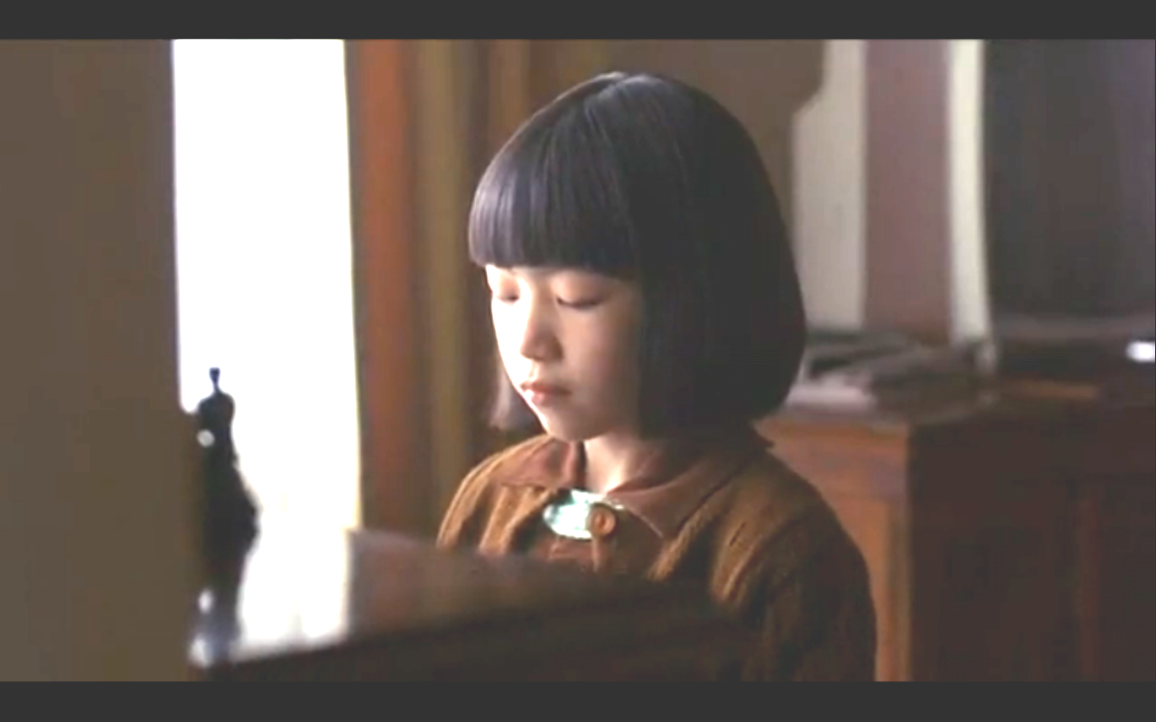
I met Old Lady Chong once, and that was enough. She had a peculiar smell, like a baby that had done something in its pants, and her fingers felt like a dead person's, like an old peach I once found in the back of the refrigerator: its skin just slid off the flesh when I picked it up. I soon found out why Old Chong had retired from teaching piano. He was deaf. “Like Beethoven!” he shouted to me: “We're both listening only in our head!” And he would start to conduct his frantic silent sonatas. Our lessons went like this. He would open the book and point to different things, explaining, their purpose: “Key! Treble! Bass! No sharps or flats! So this is C major! Listen now and play after me!”

And then he would play the C scale a few times, a simple cord, and then, as if inspired by an old unreachable itch, he would gradually add more notes and running trills and a pounding bass until the music was really something quite grand.
I would play after him, the simple scale, the simple chord, and then just play some nonsense that sounded like a rat running up and down on top of garage cans. Old Chong would smile and applaud and say, “Very good! But now you must learn to keep time!”
So that's how I discovered that Old Chong's eyes were too slow to keep up with the wrong notes I was playing. He went through the motions in half time. To help me keep rhythm, he stood behind me and pushed down on my right shoulder for every beat. He balanced pennies on top of my wrists so that I would keep them still as I slowly played scales and arpeggios. He had me curve my hand around an apple and keep that shame when playing chords. He marched stiffly to show me how to make each finger dance up and down, staccato, like an obedient little soldier.
He taught me all these things and that was how I also learned I could be lazy and get away with mistakes, lots of mistakes. If I hit the wrong notes because I hadn't practiced enough, I never corrected myself; I just kept playing in rhythm. And Old Chong kept conducting his own private reverie.
So maybe I never really gave myself a fair chance. I did pick up the basics pretty quickly, and I might have become a good pianist at the young age. But I was so determined not to try, not to be anybody different, and I learned to play only the most ear-splitting preludes, the most discordant hymns.
Over the next year I practiced like this, dutifully in my own way. And then one day I heard my mother and her friend Lindo Jong both after church, and I was leaning against a brick wall, wearing a dress with stiff white petticoats. Auntie Lindo’s daughter, Waverly, who was my age, was standing farther down the wall, about five feet away. We had grown up together and shared all the closeness of two sisters, squabbling over crayons and dolls. In other words, for the most part, we hated each other. I thought she was snotty. Waverly Jong had gained a certain amount of fame as “Chinatown's Littlest Chinese Chess Champion.”

“She bring home too many trophy.” Auntie Lindo lamented that Sunday. “All day she play chess. All day I have no time do nothing but dust off her winnings.” She threw a scolding look at Waverly, who pretended not to see her.

“You lucky you don't have this problem,” Auntie Lindo said with a sigh to my mother.

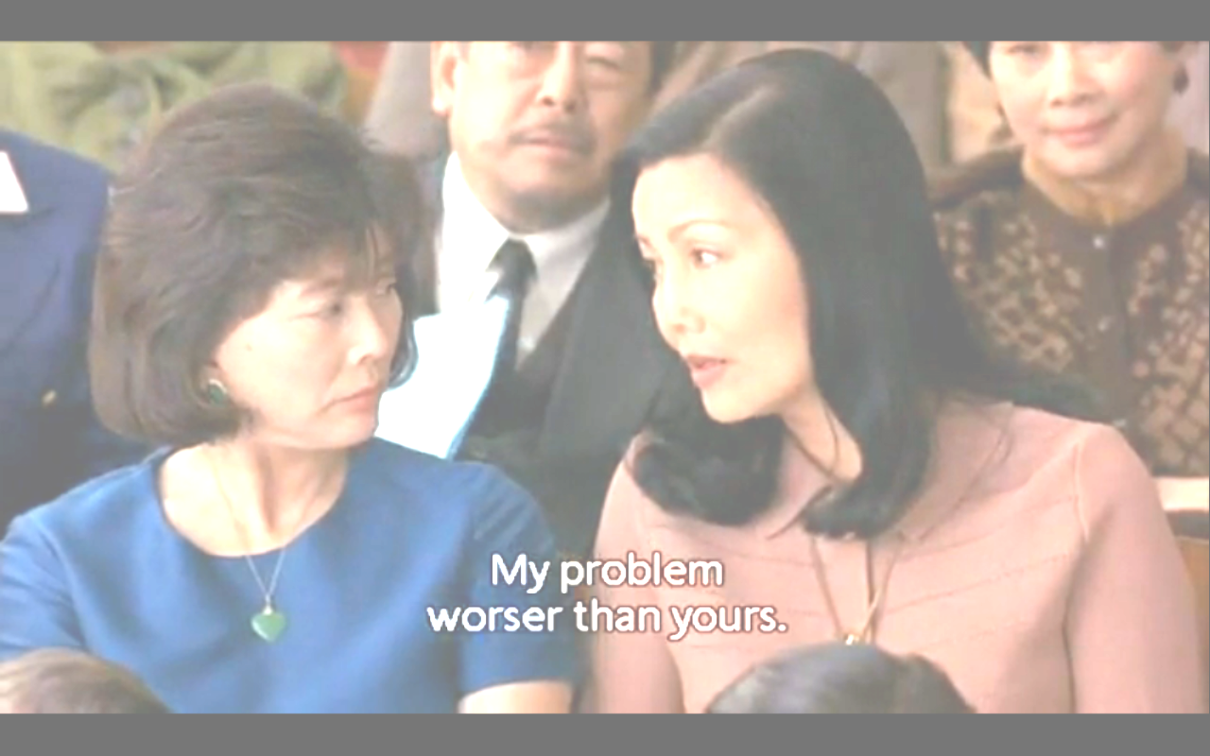
And my mother squared her shoulders and bragged: “Our problem worser than yours. If we ask Jing-mei wash dish, she hear nothing but music. It's like you can't stop this natural talent.” And right then I was determined to put a stop to her foolish pride.

A few weeks later Old Chong and my mother conspired to have me play in a talent show that was to be held in the church hall. But then my parents had saved up enough to buy me a secondhand piano, a black Wurlitzer spinet with a scarred bench. It was the showpiece of our living room.
For the talent show I was to play a piece called “Pleading Child,” from Schumann's Scenes From Childhood. It was a simple, moody piece that sounded more difficult than it was. I was supposed to memorize the whole thing. But i dawdled over it, playing a few bars and then cheating, looking up to see what notes followed. I never really listed to what I was playing. I daydreamed about being somewhere else, about being someone else.

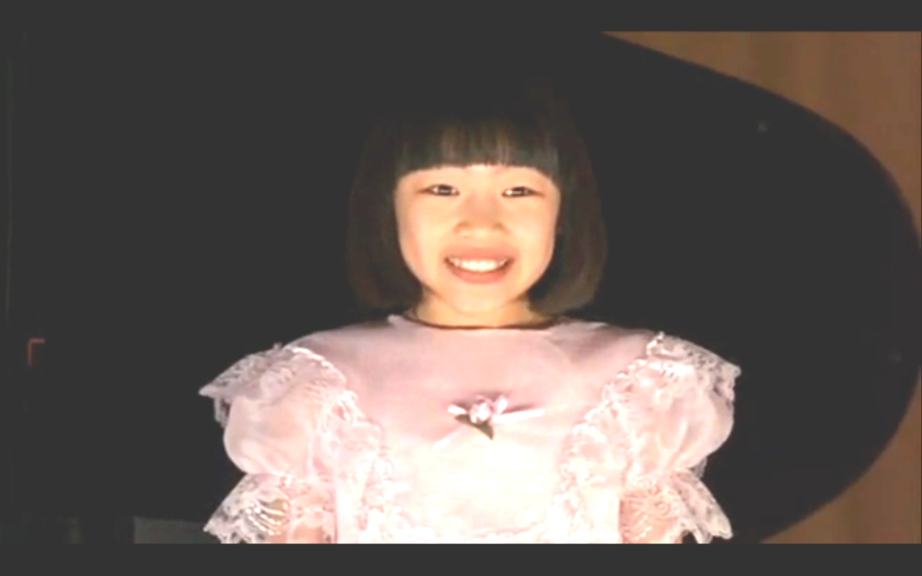
The part I liked to practice best was the fancy curtsy: right foot out, touch the rose on the carpet with a pointed foot, sweep to the side, bend left leg, look up, and smile.
My parents invited all the couples from their social club to witness my debut. Auntie Lindo and Uncle Tin were there. Waverly and her two older brothers had also come. The first two rows were filled with children either younger or older than I was. The littlest ones got to go first. They recited simple nursery rhymes, squawked out tunes on miniature violins, and twirled hula hoops in pink ballet tutus, and when they bowed or curtsied, the audience would sigh in unison, “Awww,” and then clap enthusiastically.
When my turn came, I was very confident. I remember my childish excitement. It was as if I knew, without a doubt, that the prodigy side of me really did exist. I had no fear whatsoever, no nervousness. I remember thinking, This is it! This is it! I looked out over the audience, at my mother's blank face, my father's yawn, Auntie Lindo's stiff-lipped

smile, Waverly's sulky expression. I had on a white dress, layered with sheets of lace, and a pink bow in my Peter Pan haircut. As I sat down, I envisioned people jumping to their feet and Ed Sullivan rushing up to introduce me to everyone on TV.
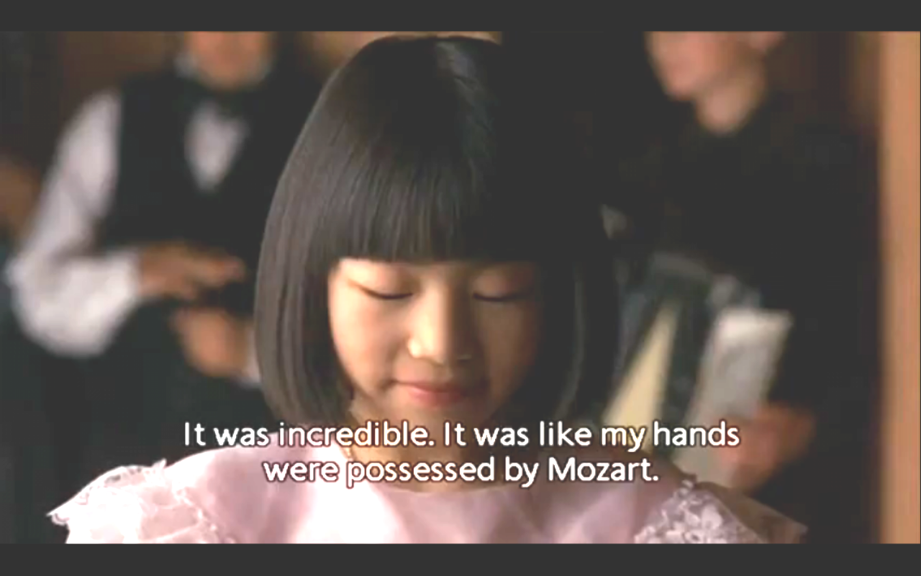
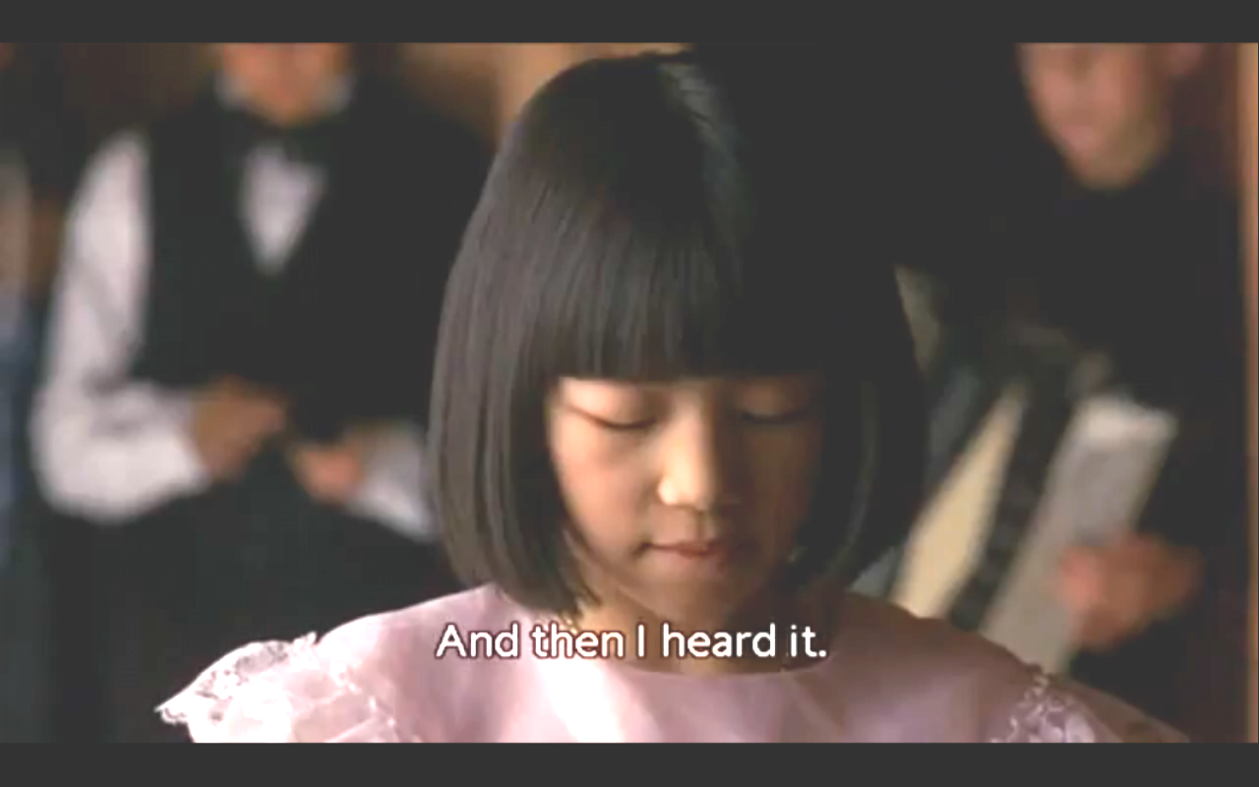
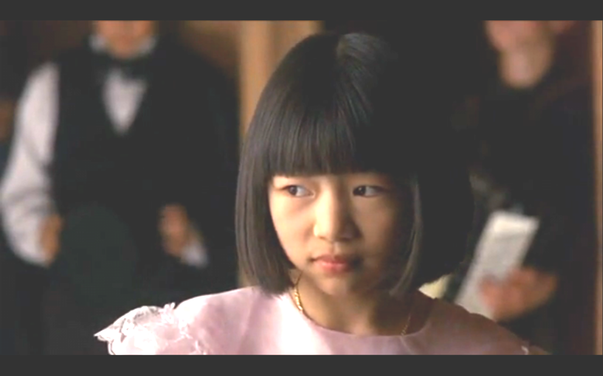
And I started to play. Everything was so beautiful. I was so caught up in how lovely I looked that I wasn't worried about how I would sound. So I was surprised when I hit the first wrong note. And then I hit another and another. A chill started at the top of my head and began to trickle down. Yet I couldn't stop playing, as though my hands were bewitched. I kept thinking my fingers would adjust themselves back, like a train switching to the right track. I played this strange jumble through to the end, the sour notes staying with me all the way.
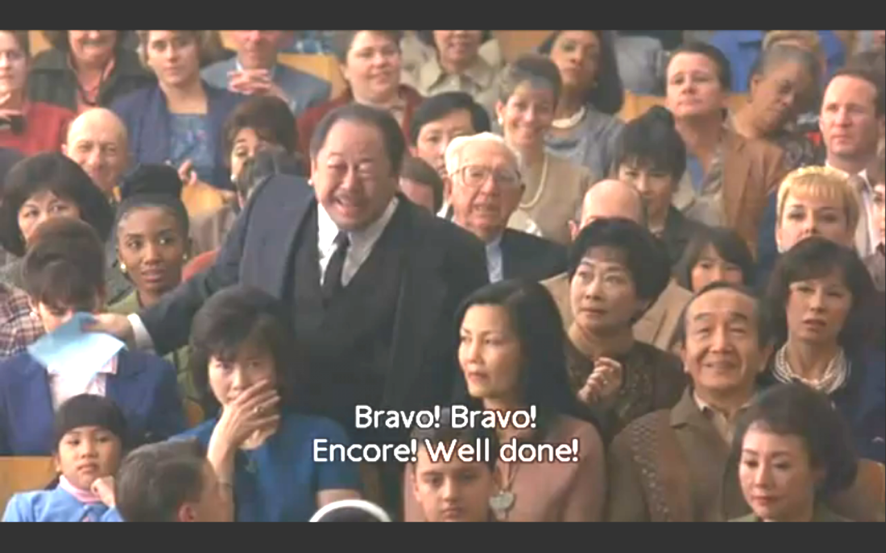
When I stood up, I discovered my legs were shaking. Maybe I had just been nervous, and the audience, like Old Chong had seen me go through the right motions and had not heard anything wrong at all. I swept my right foot out, went down on my knee, looked up, and smiled. The room was quiet, except for Old Chong, who was beaming and shouting "Bravo! Bravo! Well done!"

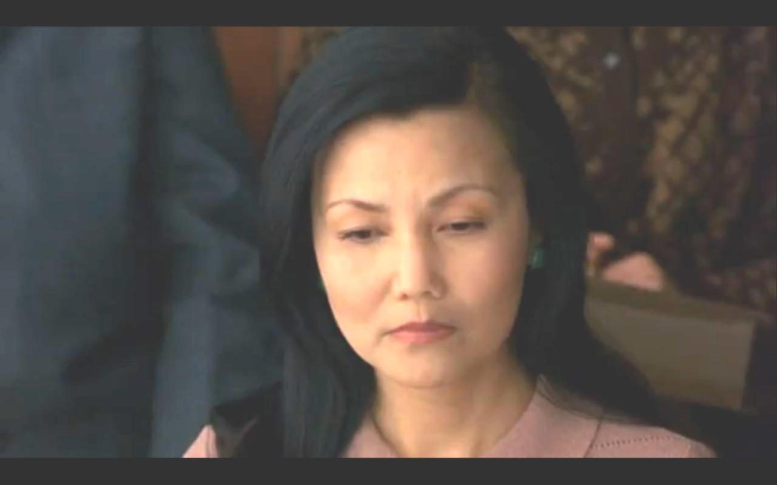
By then I saw my mother's face, her stricken face. The audience clapped weakly, and I walked back to my chair, with my whole face quivering as I tried not to cry, I heard a little boy whisper loudly to his mother. “That was awful,” and mother whispered, “Well, she certainly tried.”
And now I realized how many people were in the audience - the whole world, it seemed. I was aware of eyes burning into my back. I felt the shame of my mother and father as they sat stiffly through the rest of the show.
We could have escaped during intermission. Pride and some strange sense of honor must have anchored my parents to their chairs. And so we

watched it all. The eighteen-year-old boy with a fake moustache who did a magic show and juggled flaming hoops while riding a unicycle. The breasted girl with white make up who sang an aria from Madame Butterfly and got an honorable mention. And the eleven-year-old boy who was first prize playing a tricky violin song that sounded like a busy bee. After the show the Hsus, the Jongs, and the St. Clairs, from the Joy Luck Club, came up to my mother and father.

“Lots of talented kids,” Auntie Lindo said vaguely, smiling broadly. “That was somethin' else,” my father said, and I wondered if he was referring to me in a humorous way, or whether he even remembered what I had done.
Waverly looked at me and shrugged her shoulders. “You aren't a genius like me,” she said matter-of-factly. And if I hadn't felt so bad, I would have pulled her braids and punched her stomach.
But my mother's expression was what devastated me: a quiet, blank look that said she had lost everything. I felt the same way, and everybody seemed now to be coming up, like gawkers at the scene of an accident to see what parts were actually missing.
When we got on the bus to go home, my father was humming the busy-bee tune and my mother kept silent. I kept thinking she wanted to wait until we got home before shouting at me. But when my father unlocked the door to our apartment, my mother walked in and went straight to the back, into the bedroom. No accusations, No blame. And in a way, I felt disappointed. I had been waiting for her to start shouting, so that I could shout back and cry and blame her for all my misery.

I had assumed that my talent-show fiasco meant that I would never have to play the piano again. But two days later, after school, my mother came out of the kitchen and saw me watching TV. “Four clock,” she reminded me, as if it were any other day. I was stunned, as though she were asking me to go through the talent-show torture again. I planted myself more squarely in front of the TV.

“Turn off TV,” she called from the kitchen five minutes later. I didn't budge. And then I decided, I didn't have to do what mother said anymore. I wasn't her slave. This wasn't China. I had listened to her before, and look what happened she was the stupid one. She came out of the kitchen and stood in the arched entryway of the living room. "Four clock," she said once again, louder.
“I'm not going to play anymore,” I said nonchalantly. “Why should I? I'm not a genius.”

She stood in front of the TV. I saw that her chest was heaving up and down in an angry way.

“No!” I said, and I now felt stronger, as if my true self had finally emerged. So this was what had been inside me all along. “No! I won't!” I screamed.
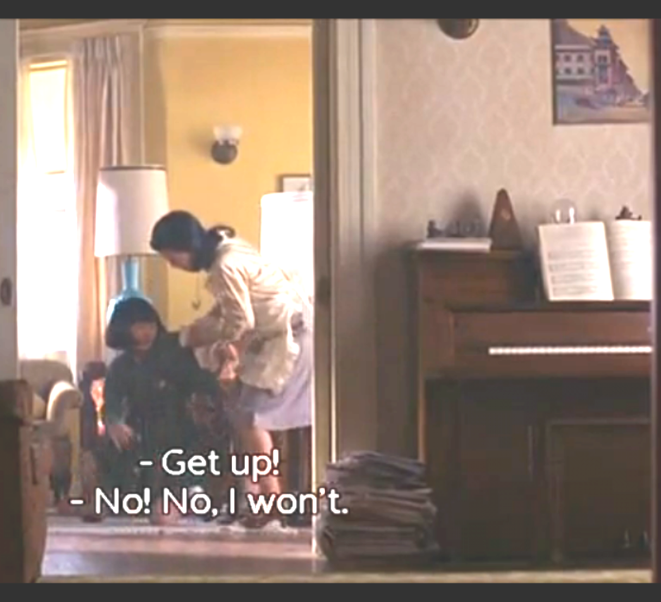
She snapped off the TV, yanked me by the arm and pulled me off the floor. She was frighteningly strong, half-pulling, half-carrying me toward the piano as I kicked the throw rugs under my feet. She lifted me up onto the hard bench.

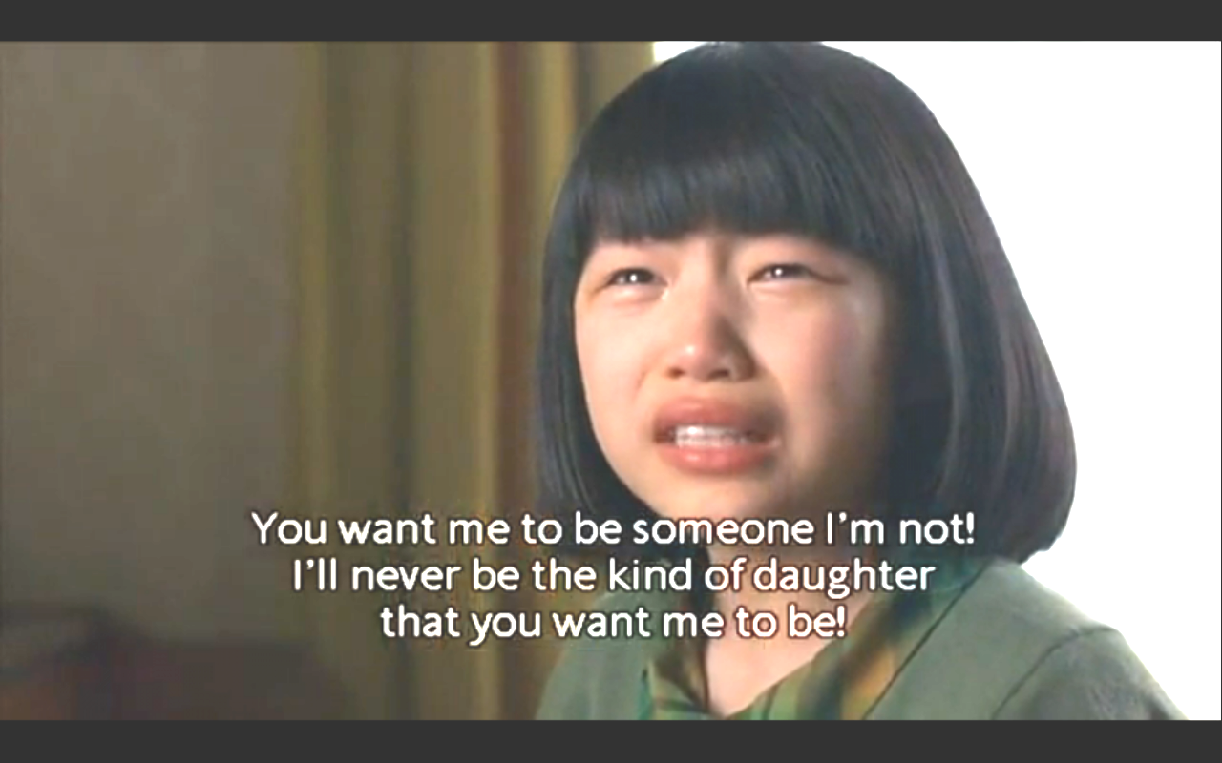
I was sobbing by now, looking at her bitterly. Her chest was heaving even more and her mouth was open, smiling crazily as if she were pleased that I was crying. "You want me to be something that I'm not!" I sobbed. "I'll never be the kind of daughter you want me to be!"
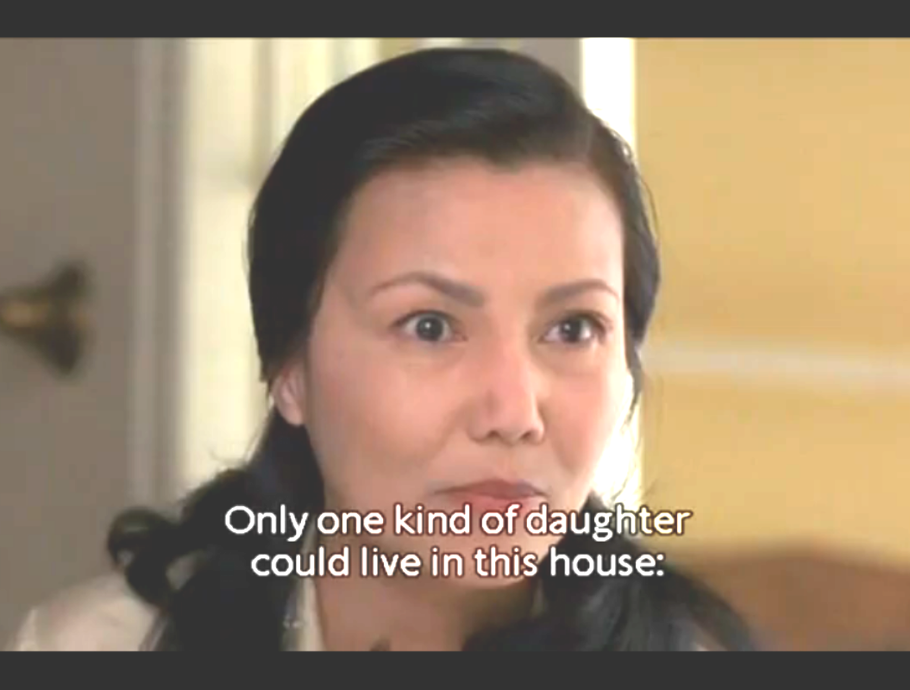
"Only two kinds of daughters," she shouted in Chinese. "Those who are obedient and those who follow their own mind! Only one kind of daughter can live in this house. Obedient daughter!"

"Then I wish I weren't your daughter, I wish you weren't my mother," I shouted. As I said these things I got scared. It felt like worms and toads and slimy things crawling out of my chest, but it also felt good, that this awful side of me had surfaced, at last.
"Too late to change this," my mother said shrilly.
And I could sense her anger rising to its breaking point. I wanted see it spill over. And that's when I remembered the babies she had lost in China, the ones we never talked about. "Then I wish I'd never been born!" I shouted. " I wish I were dead! Like them."
It was as if I had said magic words. Alakazam!-her face went blank, her mouth closed, her arms went slack, and she backed out of the room, stunned, as if she were blowing away like a small brown leaf, thin, brittle, lifeless.

It was not the only disappointment my mother felt in me. In the years that followed, I failed her many times, each time asserting my will, my right to fall short of expectations. I didn't get straight As. I didn't become class president. I didn't get into Stanford. I dropped out of college. Unlike my mother, I did not believe I could be anything I wanted to be, I could only be me.

And for all those years we never talked about the disaster at the recital or my terrible declarations afterward at the piano bench. Neither of us talked about it again, as if it were a betrayal that was now unspeakable. So I never found a way to ask her why she had hoped for something so large that failure was inevitable.
And even worse, I never asked her about what frightened me the most: Why had she given up hope? For after our struggle at the piano, she never mentioned my playing again. The lessons stopped. The lid to the piano was closed shutting out the dust, my misery, and her dreams.
So she surprised me. A few years ago she offered to give me the piano, for my thirtieth birthday. I had not played in all those years. I saw the offer as a sign of forgiveness, a tremendous burden removed. “Are you sure?” I asked shyly. “I mean, won't you and Dad miss it?”

“No, this your piano,” she said firmly. “Always your piano. You only one can play.”
“Well, I probably can't play anymore,” I said. “It's been years.”

“You pick up fast,” my mother said, as if she knew this was certain. “You have natural talent. You could be a genius if you want to.”

“No, I couldn't.”

“You just not trying,” my mother said. And she was neither angry nor sad. She said it as if announcing a fact that could never be disproved. “Take it,” she said.
But I didn't at first. It was enough that she had offered it to me. And after that, every time I saw it in my parents' living room, standing in front of the bay window, it made me feel proud, as if it were a shiny trophy that I had won back.

Last week I sent a tuner over to my parent's apartment and had the piano reconditioned, for purely sentimental reasons. My mother had died a few months before and I had been forgetting things in order for my father a little bit at a time. I put the jewelry in special silk pouches. The sweaters I put in mothproof boxes. I found some old Chinese silk dresses, the kind

with little slits up the sides. I rubbed the old silk against my skin, and then wrapped them in tissue and decided to take them home with me.

After I had the piano tuned, I opened the lid and touched the keys. It sounded even richer that I remembered. Really, it was a very good piano. Inside the bench were the same exercise notes with handwritten scales,
the same secondhand music books with their covers held together with yellow tape.

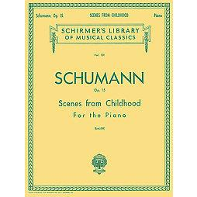
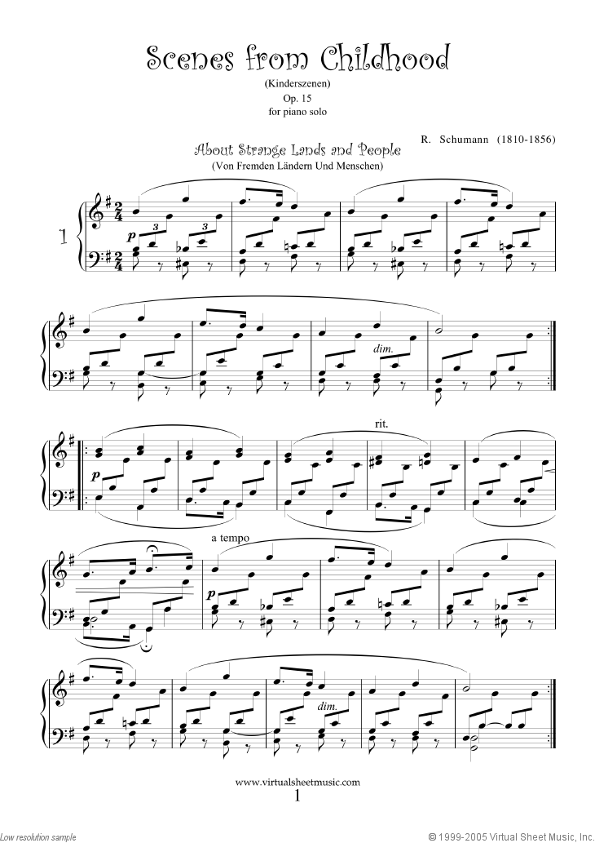
I opened up the Schumann book to the dark little piece I had played at the recital. It was on the left-hand page, "Pleading Child." It looked more difficult than I remembered. I played a few bars, surprised at how easily the notes came back to me.
And for the first time, or so it seemed, I noticed the piece on the right-hand side. It was called "Perfectly Contented." I tried to play this one as well. It had a lighter melody but with the same flowing rhythm and turned out to be quite easy. "Pleading Child" was shorter but slower; "Perfectly Contented" was longer but faster. And after I had played them both a few times, I realized they were two halves of the same song.
[1989]
***

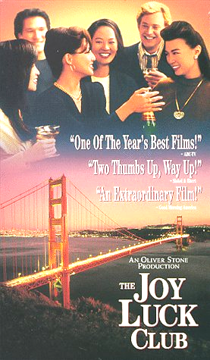
Images selected from 1993 film version directed by Wayne Wang and produced by Oliver Stone.

Starring Ming-Na Wen as the adult Jing-Mei, “June,” the first-person-narrator featured in this excerpt.

In “The Joy Luck Club,” four older women, all Chinese immigrants living in San Francisco, meet regularly to play mahjong, eat, and tell stories. Each of these women has an adult Chinese-American daughter. The film reveals the hidden pasts of the older women and explores cultural conflict and the relationships between mothers and daughters. The film is structured as a series of vignettes told from the perspectives of the different women.


